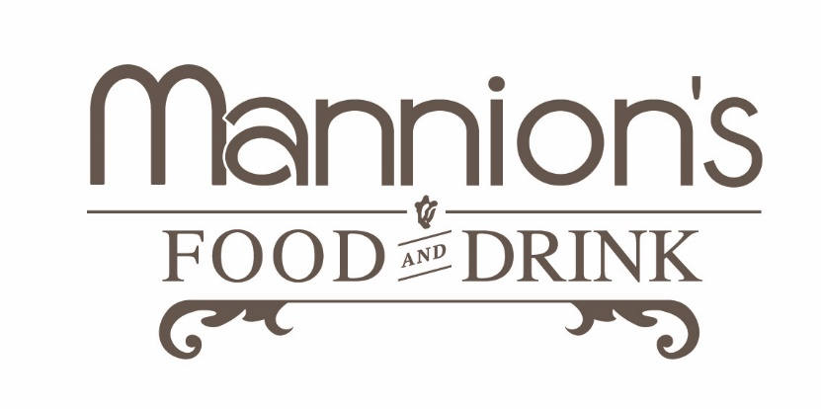

Kids Menu (Under 12 Only)
Cup of Soup with Crispy Bread €3.50
O’Neill’s Pork Sausages with Chips or Veg & Potatoes €5.00
Rosie & Jim’s Chicken Goujons with Chips or Veg & Potatoes €6.95
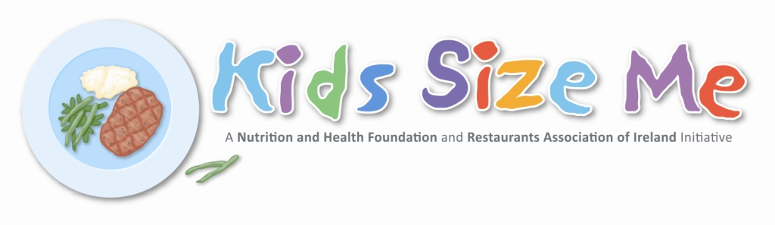
Kids Main Course (Ask Server for Options) €8.95
Roast Breast of Corn-fed Chicken, Potatoes & Veg €8.95
Pasta Tubes with Creamy Tomato Sauce €5.50
Crispy Fish Goujons in Sesame & Panko Crumb, Salad & Fries €7.50

Kids Dessert:
Featherbed Farm Strawberry & Vanilla Ice Cream w/Choc Sauce & Baby Meringue €2.50

